Gamma Phi Delta Sorority, Inc. Mourns the Passing of
Two Civil Rights Icons.

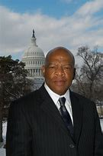
The Honorable John Lewis was a beloved icon of the civil rights movement and a well-respected Congressman. Mr. Lewis began his civil rights activism as a college student and continued this commitment for his entire adult life. He was one of the original Freedom Riders in the early days of the fight for civil rights. Mr. Lewis served as Chairman of the Student Non-Violent Coordinating Committee. He continued to fight for civil rights and social justice in the Federal government. Eventually, he decided to seek elected office. Mr. Lewis served in Congress for more than 20 years. During recent months, he bravely fought pancreatic cancer. However, he did not let that stop him from his activism. We will remember his dedication and commitment. Mr. Lewis, we thank you for the wonderful example and legacy you have left behind.

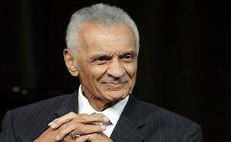
Reverend Cordy Tindell “C.T.” Vivian was a minister, author, and close friend of Rev. Dr. Martin Luther King Jr. during the Civil Rights Movement. Reverend Vivian resided in Atlanta, Georgia, and founded the C. T. Vivian Leadership Institute, Inc. He conceived and directed a program call Vision and awarded 700+ scholarships to college bound students. This program was the forerunner of the Upward Bound Program. Reverend Vivian continued to contribute to the civil rights and social justice movement throughout his life. Another soldier for social justice has taken his eternal rest. Let us remember his commitment and his legacy of service.

